**DSA ASSIGNMENT - JUNE 25**

Name - Vijay Kumar Saini

Roll.No - 23/11/EC/027

LeetCode Id - vijay_kumar_saini

GeekforGeeks - sainivij3yo0

Github Repo Link: h[ttps://github.com/vijaysaini2613/jnu-ass](https://github.com/vijaysaini2613/jnu-ass)

1. Reverse Linked List

○ Platform: GeeksforGeeks

○ Link: <https://leetcode.com/problems/reverse-linked-list/>

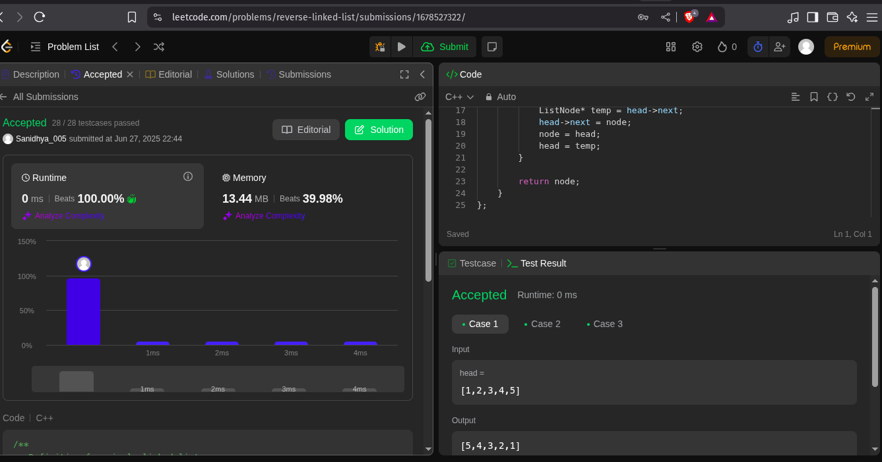

2. Linked List Cycle

○ Platform: LeetCode

○ Link: <https://leetcode.com/problems/linked-list-cycle/>

